**EEVAA Framework for DTA**

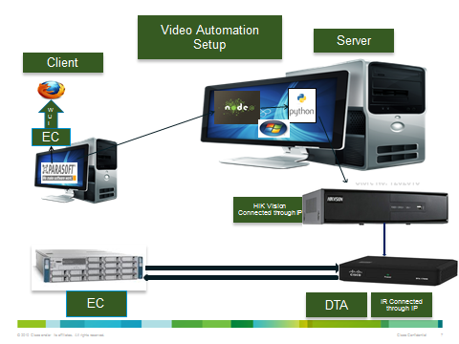

1. A PC with Parasoft running.
2. PC with Python 2.7 with other dependent libraries for EEVAA ( PIL, Opencv , numpy )

<https://www.python.org/download>

<https://pypi.python.org/pypi/numpy>

<http://www.pythonware.com/products/pil/>

<http://docs.opencv.org/trunk/doc/py_tutorials/py_setup/py_setup_in_windows/py_setup_in_windows.html>

1. Hikvision libraries imported
2. Nodejs installed .- <http://nodejs.org/download/>
3. Tesseract - <https://code.google.com/p/tesseract-ocr/>

EEVAA Framework Home Page :

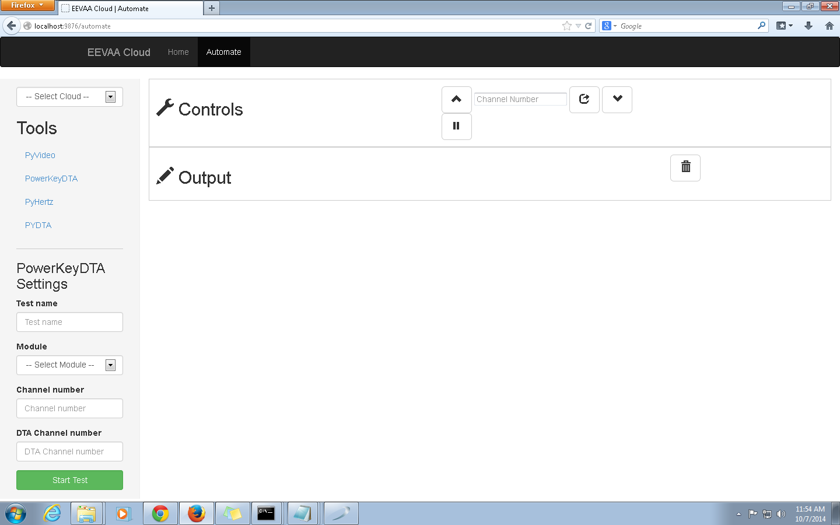

Tools :

1. PyVideo - Usage for Normal DHCT ( 8300 HD ) - The corresponding python file is pyvideo.py
2. PowerKeyDTA – Usage for DTA 271 – pydta270.py
3. PyHertz for Audio related tests
4. PYDTA – Usage for DTA 170 – pydta.py

Settings :

For DTA ( PowerKey DTA and DTA) Selections :

1. Testname – Indicates a valid unique name used for storing the images captured with the same names appended by 1 and 2 ( for eg . if test name is test then we will have Test1.jpeg and Test2.jpeg images in Images folder)
2. Module: What Test needs to be run to be selected from the dropdown.
3. Channel Number: HIK Vision Port to which the DTA is connected.
4. DTA Channel Number: Used for Channel tune, for Diag related tests make it as 0.

Tests Implemented in PyVideo :

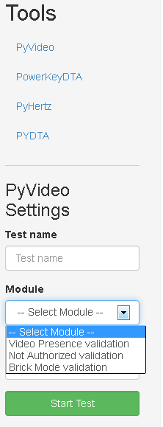

1. Video Presence for clear Video Validation.
2. Not Authorized For Not Authorized Barker Validation.
3. Brick Mode for Brick Mode Barker Validation

Power Key DTA Modules :

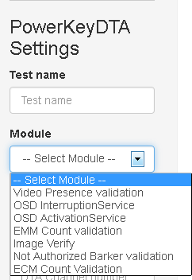

1. Video Presence for clear Video Validation.
2. Not Authorized For Not Authorized Barker Validation.
3. OSD Interruption Service for OSD Interruption Message
4. OSD Activation Service for OSD Activation Message
5. EMM Count validations for EMM Count
6. ECM Count Validation For ECM Count
7. Image Verify For Image present in the DTA.

DTA Modules:

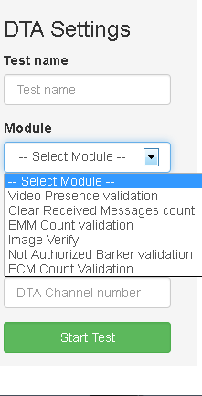

1. Video Presence for clear Video Validation.
2. Not Authorized For Not Authorized Barker Validation.
3. EMM Count validations for EMM Count
4. ECM Count Validation For ECM Count
5. Image Verify For Image present in the DTA.

Procedure:

1. Make sure the HIKVision is pingable through a public IP.
2. Irtek also has to be connected to a public IP.
3. Make sure the DNCS is accessible from WUI ( Firefox )
4. Run the server.js script from EEVAA Folder (node server.js ) in the server PC.
5. From Parasoft invoke the test and verify.
6. The VideoPresence script in parasoft will invoke the corresponding python code according to the selections made in UI and return the values back to UI.
7. With the values returned validations can be made in Parasoft.
8. Path for captured images will be C:\EEVAA\public\images\captures
9. Path for the Python functions will be C:\EEVAA\python

Test 1: Check for Video Presence:

1. Create a Source, Source Definition.
2. Create a SAM Service for the source created and assign it to the channel map assigned to the DTA.
3. Tune to the channel in DTA Box and verify for Video Presence.

Test 2: Check for Not Authorized Channel.

1. Create an Encrypted source and create a Source definition foe the source.
2. Create an Unlimited segment.
3. Create a SAM Service for the source.
4. Assign the SAM Service to the channel map assigned to the channel map.
5. Create a Package and assign the segment to the Package.
6. Tune to the channel in the DTA.
7. Verify for Not authorized Barker validation.
8. Assign the package to the DTA by navigating to DHCT Provisioning Page in the EC.
9. Do a DHCT Instant Hit.
10. Wait for some time or perform a channel up / down and tune to the same channel.
11. Verify Video Present and ECM Count Increase.

Sample EEVAA Output screen:

Test 3: Image Verification:

1. Check for the current version of the Image from the drag page.
2. Trigger an Image download from the DNCS for the specified DTA.
3. Wait for a specified time and check for the Image version.
4. Check step 1 value and step 3 values are not same.

Test 4: EMM Verification:

1. Verify the EMM Count from the diag Page.
2. Perform a DHCT Instant hit to the DTA Connected to the IR.
3. Verify the EMM Count, suite verifies both count are not same.

Test Verification:

1. From Parasoft create Tests foe DNCS Related Steps.
2. Launch EEVAA Url from EEVAA Folder ip and port (for eg. if ip is 10.143.32.102 , http: 10.143.32.102 :9876 )
3. We get the EEVAA Web page.
4. Make the necessary selections and start the test.
5. The results will be displayed in WUI.
6. The results are extracted in Parasoft and verified.
7. Steps 2 to 6 are also done in Parasoft as a scenario.

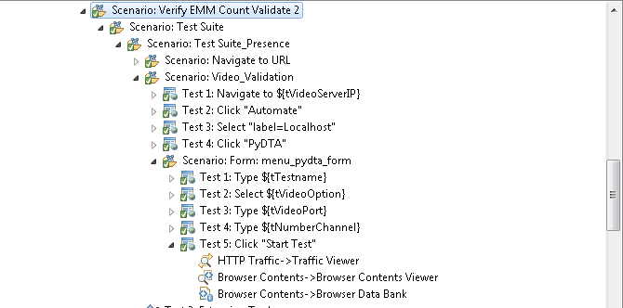

Sample screen shot from Parasoft.

Sample screen shot from EEVAA

